Tribunal File No.: 2010-07633-I

HUMAN RIGHTS TRIBUNAL OF ONTARIO

MICHAEL JACK
Applicant

- and -

HER MAJESTY THE QUEEN IN RIGHT OF ONTARIO, AS REPRESENTED BY THE MINISTRY OF COMMUNITY SAFETY AND CORRECTIONAL SERVICES OPERATING AS THE ONTARIO PROVINCIAL POLICE

Respondent

SUBMISSIONS OF THE APPLICANT

REASONABLE PROSPECT OF SUCCESS

Introduction
- The applicant is a member of a racialized minority group in that he is a Russian-Jew who speaks English with a thick Russian accent. Upon immigrating to Canada from Israel in the year 2000 he put himself through a higher education at Trent University and joined the Ontario Provincial Police (OPP) as a probationary recruit in 2008. During his one year probationary term which began at the Peterborough County OPP Detachment in January 2009, he was subjected to racial discrimination in several protected grounds namely: race, ancestry, place of origin, ethnic origin, citizenship, and alleged association with a person identified by a protected ground.

- His thick Russian accent forms much of the basis for the protected grounds of race, ancestry and place of origin. His monthly evaluations were directly affected by discriminatory treatment that violated the direction set out by Ontario Provincial Police Orders (OPP Orders). He was terminated from employment on December 15, 2009, as a result of an alleged failure to meet the performance and conduct requirements of a probationary recruit regarding his monthly Performance Evaluation Reports (PERs).

- As a result of his treatment he filed an application with the Human Rights Tribunal of Ontario (HRTO) under the Human Rights Code that resulted in this hearing. After 10 days of testimony before the Vice Chair, Keith Brennenstuhl the applicant testimony closed and submissions were ordered pursuant to the Case Management Guidelines.

- Based on the testimony provided, the exhibits adduced and the exhibits that the applicant reasonably expects to present, the applicant believes that contrary to the respondent’s position there is a reasonable prospect of success and makes the following submissions in support of this belief.

Legislative Framework governing Reasonable Prospect of Success
- The Ontario Human Rights Code (Code)states that:
Every person has a right to equal treatment with respect to employment without discrimination because of race, ancestry, place of origin, colour, ethnic origin, citizenship, creed, sex, sexual orientation, age, record of offences, marital status, family status or disability. R.S.O. 1990, c. H.19, s. 5 (1); 1999, c. 6, s. 28 (5); 2001, c. 32, s. 27 (1); 2005, c. 5, s. 32 (5).

- The Code also states that:

(2) Every person who is an employee has a right to freedom from harassment in the workplace by the employer or agent of the employer or by another employee because of race, ancestry, place of origin, colour, ethnic origin, citizenship, creed, age, record of offences, marital status, family status or disability. R.S.O. 1990, c. H.19, s. 5 (2); 1999, c. 6, s. 28 (6); 2001, c. 32

- With respect to reprisals the Code states:

Every person has a right to claim and enforce his or her rights under this Act, to institute and participate in proceedings under this Act and to refuse to infringe a right of another person under this Act, without reprisal or threat of reprisal for so doing. R.S.O. 1990, c. H.19, s. 8.

- With respect to discrimination by association the Code states:

A right under Part I is infringed where the discrimination is because of relationship, association or dealings with a person or persons identified by a prohibited ground of discrimination. R.S.O. 1990, c. H.19, s. 12.

- The HRTO is governed by policies enacted by the Ontario Human Rights Commission (OHRC) in 2009 that elaborate on factors influencing discrimination of a protected ground namely language and or foreign accents. The OHRC policy on language or accent related grounds of discrimination is:

The first language we learn is frequently the language spoken by our parents or guardians and others who take care of us as children. There is almost inevitably a link between the language we speak or the accent with which we speak a particular language on the one hand, and our ancestry, ethnic origin or place of origin on the other.
A person's accent is also often associated with her or his "mother tongue" or place of origin. Because a person's accent is usually related to her or his ancestry, ethnic origin or place of origin, the Code can be infringed when someone is denied employment, service, housing, or is otherwise discriminated against because of an accent. In these kinds of situations, the underlying discrimination is often actually based on ancestry, place of origin and, or ethnic origin.

- In the interests of the public the protected grounds of an individual under the Code was more simply captured in a brochure from the OHRC recognizing and explaining that racism & racial discrimination have some differences in that racism is,

‘ … a broader experience and practice than racial discrimination. It is an ideology that either directly or indirectly asserts that one group is inherently superior to others.’

Emphasis added

- Racial discrimination on the other hand as explained in the same brochure is,

‘ … a legally prohibited expression of racism. It is any action based on a person’s race, intentional or not, that imposes burdens on a person or group and not on others, or that withholds or limits access to benefits available to other members of society in areas covered by the Code. Race only needs to be one factor in a situation for racial discrimination to have occurred.’

Emphasis added

- In another brochure put out by the OHRC Racial Harassment is explained in simple terminology.

‘Racial harassment” means that someone is bothering you, threatening you or treating you unfairly because of your:
• race
• colour
• ancestry
Racial harassment may also be connected to where you were born, where you lived before moving to Ontario, your religious belief, your ethnic background, citizenship, or even your language. It is against the law for anyone to harass you, insult you, or treat you unfairly for any of these reasons.
Racial harassment can happen when someone:

• makes racial slurs or jokes
• ridicules or insults you because of your racial identity
• puts up cartoons or pictures that degrade persons of a particular racial group
• calls you names because of your race, colour, citizenship, place of
origin, ancestry, ethnic background or creed

Racial harassment can have a bad effect on, or “poison”, the places where you live, work or receive services. Even if the harassment is not directed at you, it can still poison the environment for you and others. How do you know if the environment is poisoned? One way is to look at the effect of negative comments or actions. For instance, if certain racial slurs or actions make you or others feel uncomfortable in the workplace or fearful of returning to work, this could indicate that the work environment is poisoned.

Emphasis added

Establishing a Prima Facie Case
- The applicant has the initial burden in establishing a prima facie case that he was subjected to adverse differential treatment on the basis of his race, ancestry, place of origin, ethnic origin, citizenship, and association with a person identified by a protected ground ethnic or national origin.
- A prima facie case is one that covers the allegations made and which, if the allegations are believed, is complete and sufficient to justify a verdict in the applicant’s favor in the absence of an answer from the respondent.,

- The Tribunal must be mindful that dismissal of the application is not merely based on what evidence is in the applicant’s possession only, but also on what is reasonably expected to be presented.

- In considering what evidence is reasonably available to the applicant, the Tribunal must be attentive to the fact that in some cases of alleged discrimination information about the reasons for the actions taken by the respondent is within the sole knowledge of the respondent. Evidence about the reasons for actions taken by the respondent may sometimes come through the disclosure process and cross-examination of the people involved. The Tribunal must consider whether there is a reasonable prospect that such evidence may lead to a finding of the discrimination.

- As the Tribunal reasoned in Hendersholt v. Ontario (Community and Social Services), 2011 HRTO 482 at para, 60:
The decision in O’Malley does not direct a statutory human rights adjudicator to conduct an analysis of the prima facie as a water-tight compartment. In other words, the Tribunal is not required to hear the applicant’s evidence first, determine that it meets the test in O’Malley, and only then call on the respondent to provide an explanation. Indeed, it is not uncommon for elements of the applicant’s burden to be met through the evidence tendered by the respondent since the respondent is often in the position of having more access to the relevant information.

- The onus then shifts to the respondent to provide a reasonable explanation that demonstrates either that the alleged discrimination did not occur as alleged or that the conduct was somehow non-discriminatory (Morris v. Canada (Canadian Armed Forces) 2005 FCA 154 at para. 26). The Tribunal must then determine, on a balance of probabilities, whether the allegation of discrimination has been substantiated.

- Human rights law recognizes that a respondent’s non-discriminatory explanation may in fact be erroneous or a pretext for discrimination (as will be pointed out further along in this submission when references are made to the respondent’s response to the application).

- A successful claim of reprisal requires an applicant to show that it was the intention of a respondent to take action in reprisal for asserting Code rights. Discrimination or reprisal need not be the only or even the principal factor in a respondent’s decision or actions, but an applicant must show that it was one of the factors.

Applying the Evidence to the Legal Framework

July 2008 to January 2009

- The applicant testified that being born in Russia and living in St. Petersburg (formerly Leningrad) for 17 years he learned to speak Hebrew and English later in his life and hence speaks both languages with a thick Russian accent. He immigrated with his parents to Israel where he went to a Nautical school and then served 3 years in the Israel Navy as a marine electrician. The applicant also testified that, in light of a role as a marine electrician, he was never exposed to any combat duty.

- Living in the middle-east and serving in the Israeli Navy he testified as to how one is literally attached to their assigned personal firearm and had to carry it around even when off duty and even if they went shopping for anything in a mall.

- The applicant’s examination-in-chief was that shortly after signing the offer of employment he attended the OPP’s Peterborough Detachment to introduce himself. He was invited by Constable Marc Gravelle (Cst. Gravelle) on a ride-along and later by Cst. Pollock on a second ride-along. At the end of each ride-along the officers dropped the applicant off at home and while offering them some refreshments the officers were shown the applicant’s home and his gun collection. Having told them about being a collector of vintage forearms he merely wanted to show them his collection in the hopes that they would be impressed as to how safely and securely they were stored.

- That innocent action of showing his vintage firearms collection to Cst. Gravelle caused him to be labeled as ‘gun happy.’ The applicant learned of this reference to him early when his references contacted him about being questioned a second time by OPPs background investigation staff in Orillia about the applicant being a ‘gun happy’ person.

- Cross-examination of Cst. Gravelle and his supervisor (personal respondent), Sergeant Brad Rathbun (Sgt. Rathbun) on an email discovered in the respondent’s disclosure and one that the applicant reasonably expects to enter as an exhibit will show that Cst. Gravelle fed his supervisor lies about the applicant that in turn caused his supervisor to make some ‘hair raising concerns’ about a Russian recruit coming to the detachment in the near future.

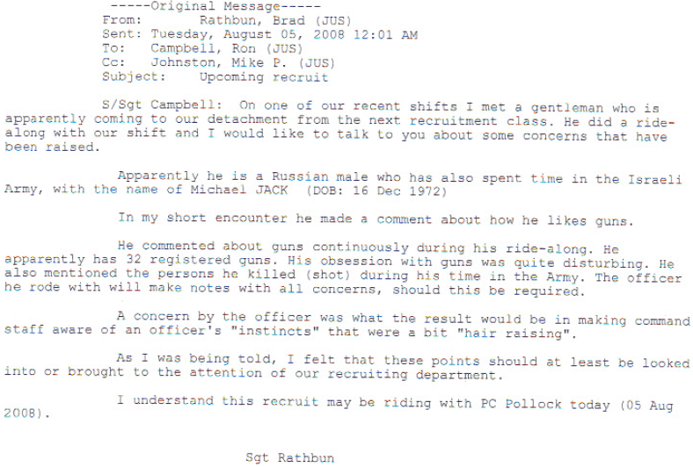

- Cross-examination of these two personal respondents regarding that email will reveal prejudices and racial discrimination towards the applicant. Being that the applicant testified that he attended Peterborough detachment on three separate occasions, initially for the purpose of introducing himself and then for the two ride-alongs with the officers, it stands to reason that he ought to have been known and identified by ‘probationary recruit Michael Jack or Jack’. However, Sgt. Rathbun specifically focuses on the applicant’s race, ancestry and place of origin by referring to him in paragraph two as, ‘… the Russian male who has spent time in the Israeli Army, with the name of Michael JACK (DOB: 16 Dec 1972).’

- There is only one explanation for why Sgt. Rathbun has included the date of birth of the applicant right after his name. So as to make it easier for the recipients of the email to do a quick check of the applicant on the police databases without having to spend time searching for it. Had the subject of the email been a Canadian born person, e.g. Mike Johnston, Sgt. Rathbun would not have referred to him in paragraph two as ‘the Canadian male who has spent time in the Canadian Army, with the name of Michael FREI (Date of Birth).’

- Based upon the last sentence in that email it is an irrefutable fact that it was Cst. Gravelle that fed all the lies and exaggeration to Sgt. Rathbun who in turn believed it and fed them to management at the detachment.

- Considering that Cst. Gravelle had only just met the applicant for the first time while on duty the cross-examination of Cst. Gravelle will reveal a marked change in his disposition towards the applicant. One of a welcome as evidenced by the applicant’s testimony with an invitation for a ride-along. Then some 10 to 12 hours later a marked change as evidenced in the lies contained in paragraphs 3 and 4 of that email.

- The applicant’s testimony and subsequent cross was as candid as that of any reasonable person with the same aptitude. He testified that while he did not remember exactly what he discussed regarding guns, as a collector of vintage firearms he probably would have talked about the history of various firearms. His testimony revealed that he gleaned this knowledge from a manual on firearms that he had and one that he often read. Hence, the question to be considered here is what caused this change in the disposition of Cst. Gravelle towards the applicant?

- Finding out what caused this noticeable change in disposition towards the applicant is something that ought to be explored by this Tribunal after determining that there is a reasonable prospect of success. Regardless, the lies in the email do speak of racism ipso facto expressed by racial discrimination of the applicant’s protected grounds of race, ancestry, place of origin for certain unwritten facts stand out:

- The applicant has never served in the Israeli Army. His testimony along with the supporting documentation confirm that he served in the Israeli Navy and so there would have been no possible reason for him to say Army as opposed to Navy other than it being a lie.
- Another lie that the applicant testified to was the fact that he has never ever seen or experienced combat duty so how could he have ‘killed (shot) people’.
- Yet another lie was that he only had 22 registered firearms and not 32.
- In order for one to talk about the ‘people’ they ‘killed (shot)’ such a person would have to be providing some detailed information to quantify the terminology of ‘he talked about the people he …’.
- The effects of those lies did raise concerns as to the sanity and or state of mind of the applicant as referenced by the wording ‘the officer’s instincts as being hair raising’
- The hours spent in the confines of a vehicle during the ride-along were not done in silence and even though the applicant may not remember all that was discussed, the fact that he talked, and did talk with a thick Russian accent (that had to have been amplified in light of the relative tight confines of the vehicle) had to have been an impacting factor in Cst. Gravelle’s concluding disposition towards the applicant. That disposition was one of contempt, disdain and dislike as evidenced in the lies he feeds his supervisor.

- All Sgt. Rathbun had to do was run the applicant’s name in the Canadian Firearms Registry Online (CFRO) database from the computer he had on his desk and he would have found out that the applicant only had 22 registered firearms and not 32. Hence, he would have been able to question the validity of the information he had received from Cst. Gravelle and placed in the email to detachment management. But he failed to do that only because he did not believe that Cst. Gravelle was feeding him lies.

- That email (‘original email’) did affect the final disposition of Sgt. Rathbun towards the applicant. Where he initially referred to the applicant in the opening paragraph as a ‘gentleman’ he no longer felt that way about the applicant. That first paragraph is devoid of racism whereas the remainder is rift with racism in the form of prejudice and racial discrimination.

- The applicant expects to present further documentary evidence in the form of emails and summaries as a result of that original email from Sgt. Rathbun that will establish a direct link to the racial discrimination he was subjected to and was going to be subjected to when he started his probationary term at the Peterborough Detachment. The further documentary evidence will show how that original email did develop into a plan/direction/order that came from command staff in Orillia giving direction to the management at the detachment level.

- That email that was shared with the Detachment Operations Manager, Staff Sergeant Ronald Campbell (S/Sgt. Campbell) and Detachment Commander, Inspector Mike Johnston (Insp. Johnston) did have an impact on them as well as on command staff in Orillia. This is evident in the subsequent communications of Insp. Johnston to the command staff. He did share the same concerns as Sgt. Rathbun of the applicant and provided direction to the operations manager and suggested that command staff in Orillia look into the concerns. Command staff in Orillia did develop the same concerns as Insp. Johnston and so they planned to have a second background investigation done on the applicant including a second in-person interview with the OPP’s psychologist, Dr. Denis Lapalme. Arrangements were made regarding when this second interview of the applicant was to take place.

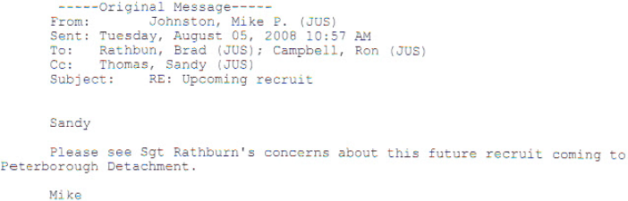

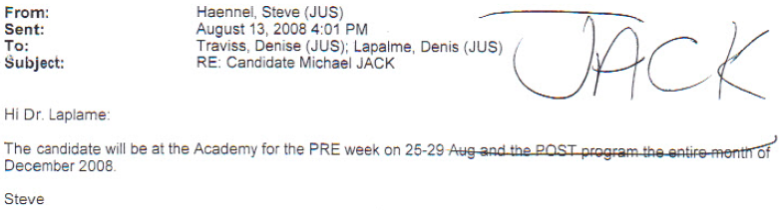

- The applicant’s testimony was that the OPP in conducting a second background investigation also contacted the President of the Peterborough Fish and Game Association, Ken Prentice, to find out if the applicant was a “gun-happy” person. The applicant testified that Mr. Prentice conveyed this information to him sometime in the spring of 2009. He told the applicant that he had been asked whether he had observed anything inappropriate about him with respect to handling firearms and following gun-safety procedures and he said that he had not. However, the OPP failed to include the summary of this interview in their disclosure.

- The applicant testified that though he had never known it at the time he then knew why he was separated from the rest of his class and escorted out on his first day at the PPA in Orillia. His testimony was that he was alarmed at the urgency and formality of the process and naturally asked what this was all about. The instructor escorting him, Mr. Peter Shipley, responded with a question, “If you have anything to tell me, tell me now”. The applicant responded that he had nothing to hide and did not have anything to tell.

- The cumulative effect of these documents that the applicant reasonably expects to present along with exhibit 90, will-say of Mr. Mark Greco (wherein Cst. Marc Gravelle refers to the applicant as a Crazy Russian) and exhibit 91, statement of Sgt. Jason Postma (regarding the existence of the applicant’s nickname “Crazy Ivan” at the Peterborough County OPP detachment) do establish links to the following protected grounds:
  - Race,
  - Ancestry,
  - Place of origin,
  - Ethnic origin

- Once in the office of the psychologist he soon was advised that one of the two Peterborough County OPP officers he had previously had a ride-along with furnished information to the management raising the inference that maybe the OPP made a mistake in granting employment to the applicant. This all had to do with the defamatory email from Sgt. Brad Rathbun.

- The lies in that one email stereotyped him as possibly being ‘crazy’, crazy due to his race, ancestry and place of origin. He was treated differently than the rest of the probationary recruits in that he was made to undergo a second background investigation and a second psychological assessment. This is not the normal practice for all the recruits. However, it was rather very different for the applicant.

- This stereotyping and differential treatment was the foundation for a poisoned work environment at the start of his probationary term at the Peterborough OPP Detachment.

- The testimony of the applicant and these emails that the applicant reasonably expects to present will show that Sgt. Rathbun believed that, since the applicant was from the Middle East and had a supposed fascination with guns and along with having served in the Army wherein he killed people and since the Middle East was often depicted in world news as being in war, this was new information that the OPP was not aware of. He further believed that if the OPP only knew this information then they would have had second thoughts about granting him employment.

- There was a presumption of guilt based on the lies fed to Sgt. Rathbun who in turn believed the lies for he stated in his email that the information conveyed was hair raising and alarming. Furthermore, the response from the instructor who led the applicant to the office of the OPP’s psychologist, Dr. Lapalme also conveyed the presumption of guilt.

- Though the second background investigation and a second in-person psychological assessment exonerated the applicant, it was not enough for the respondents to accept the determination of the background investigation and the assessment by the OPP’s psychologist, but rather believe that something may still not be right about the applicant and so they decided to keep him under surveillance when he arrived at the detachment.

- In the case of J. Nassian v. Peel Regional Police Service the Tribunal further found that Richard Elkington, a Peel police officer, conducted a discriminatory investigation that include:

- Stereotypically assuming that a Black suspect might not speak English,
- Assuming that the White security guard was telling the truth and that the Black suspect was not, without properly looking at all the evidence, including a videotape of the alleged theft, which exonerated her,
- Adopting an “assumption of guilt” approach to the investigation by immediately demanding that Ms. Nassiah produce the missing item,
- Unnecessarily arranging for a second body search after the first one had demonstrated that she did not have the allegedly stolen item,
- Continuing with the investigation, rather than releasing Ms. Nassiah, even after the second body search confirmed that she did not have the stolen item.
- The applicant testified to this at length during his examination-in-chief and it remained unshaken through the cross-examination and for the most part uncontested. He also testified as to the effects of this discriminatory stereotyping and differential treatment for his testimony was that,
‘… he felt something was not right on his first day of employment at the detachment.’
Emphasis added
- The applicant’s testimony and the aforementioned emails and documents that he reasonably expects to present do affirm the allegations in his application. In the ensuing investigation that formed the basis for the respondent’s response the individual respondents did lie as revealed in their response to the allegations.
Respondent’s Response to the Application (HRTO 2010-07633-I), paragraph 28:
Respondent’s Response to the Application (HRTO 2010-07633-I), paragraph 32:
Respondent’s Response to the Application (HRTO 2010-07633-I), paragraph 46

- It was only after the applicant shared evidence of the nick name of “Crazy Ivan” that the respondents admitted to its existence.

- The applicant testified that while at the Ontario Police College (OPC) he learned the identity of the other three probationary recruits that were going to be starting at Peterborough OPP Detachment. They were Canadians by birth (testified to this fact towards the end of his examination-in-chief) and had met with their respective coach officers in person already and despite the fact that the applicant contacted his coach officer twice he received no response and neither did he have the same benefit of meeting him in person.

- That innocent action of him showing his registered vintage firearms collection to Cst. Gravelle caused him to be labeled as ‘gun happy.’ That defamatory email from Sgt. Rathbun is what sparked a flame of disdain and ultimate hatred of the applicant that gave rise to him being treated very differently from the rest and eventually forced to resign.

- The applicant testified to the effects of this racial discrimination that he experienced this early in his brief tenure with the OPP. He testified that on August 25, 2008, while at the PPA in Orillia, during one of the orientation sessions the class was asked to introduce themselves one by one. The applicant said that there were 109 recruits in the auditorium. The orientation session was conducted by Sgt. Tozser. When it was time for him, he stood up and briefly introduced himself to the class. Before he could finish saying what he wanted to say about himself, Sgt. Tozser interrupted him by addressing the audience in a clear and loud voice, ‘Did anyone get that?’ She then addressed him personally, ‘You have a very thick accent. You have to speak very slowly.’ The whole class witnessed that.

- The applicant’s testimony was also that he had never received such comments during his entire tenure at Trent University. The effects of those comments from the instructor which were directly related to his accent thereby directly linked to racial discrimination of the protected grounds of race, ancestry, place of origin and ethnic origin made him feel very embarrassed, humiliated and left him perspiring even though the auditorium was air conditioned.

- The respondent through cross-examination attempted to negatively portray the applicant as being ‘gun happy’ based on his past firearms collection. However, his testimony revealed that he was offended by such a characterization and he pointed out that first living in a war zone area of the world (Israel) while serving in the military one is expected to carry around his firearm at all times to the point that (as he stated), ‘you are attached to your firearm like it was a third hand.’ Second, having registered firearms in his possession all of which were properly stored and maintained was his legal right in Canada. Third, he even pointed out that one of the recruits he befriended while at the Provincial Police Academy (PPA) had over 50 firearms in his collection and another recruit had served in the Canadian Army and even had been exposed to combat during his time in his deployment in the Afghanistan. Both of them were Canadian born individuals and none of them was labeled as a ‘gun happy’ person. His testimony during examination did reveal that he regarded this term as being rather discriminatory.

- The applicant reasonably expects to present the following emails between some of the personal respondents and command staff in Orillia from September 4 to 24, 2008 and the Internal Briefing Report (‘documents’) detailing the results of the investigation stemming from that original email from Sgt. Rathbun that will establish a prima facie case of racism and racial discrimination of the applicant in the protected grounds of race, ancestry, place of origin, and ethnic origin by differential treatment. Furthermore, they will serve to establish irrefutable evidence of systemic discrimination and racial profiling towards the applicant during the cross-examination of certain witnesses:
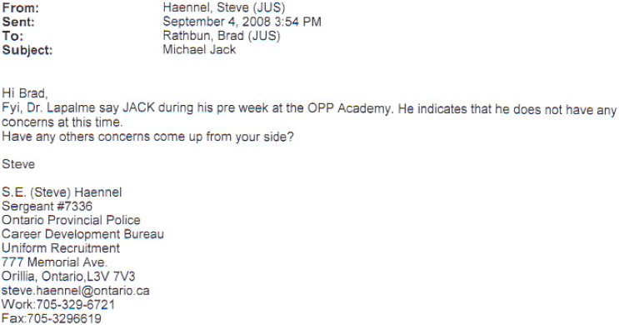

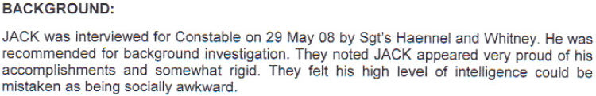
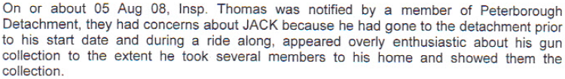
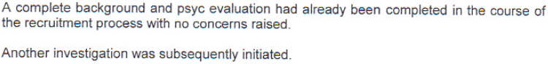
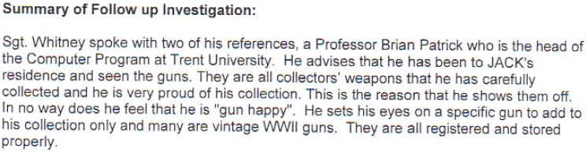
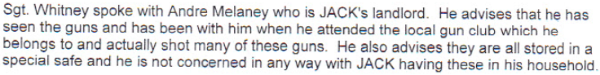
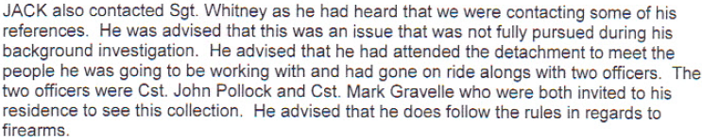

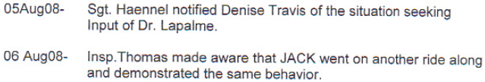

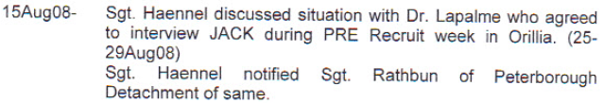
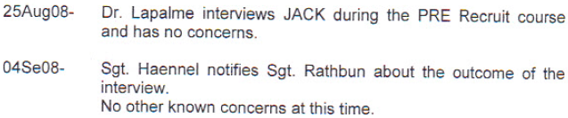
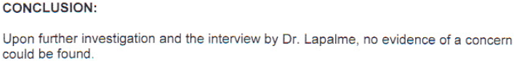
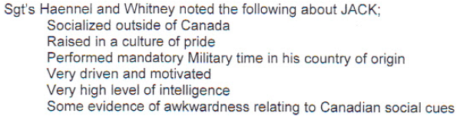

- That original email from Sgt. Rathbun did poison the future environment of the applicant and as referenced in the opening paragraph of the Internal Briefing Report. The testimony of the applicant was that he sensed that something was not quite right on his first day at the detachment.

- The conclusion in that Internal Briefing report will afford further evidence of racial discrimination by stereotyping of applicant based on the protected grounds. Race, ancestry, place of origin and ethnic origin come into play here because in stating that the applicant showed evidence of awkwardness in adjusting to Canadian social cues implied that there was a requirement by the organization and in this case the OPP for the applicant to adjust to Canadian social cues but he was having difficulty doing that. As such it the applicant submits that it also meets the elements of systemic discrimination.

- These ‘documents’ reveal that Sgt. Rathbun was emailed the disposition of Dr. Lapalme’s second assessment of the applicant on September 4, 2008, by Sgt. Steve Haennel. However, on August 11, 2008, command staff (Insp. Denise Travis) received an email from Dr. Lapalme advising that he should work with the Academy on this one along with recruitment. He specifically stated,

‘The position should be as such: we have offered the candidate employment conditional on his passing Academy and OPC and probationary time.’
Emphasis added

- These ‘documents’ also show that command staff in Orillia were privy to the disposition of the investigation related to that original email from Sgt. Rathbun on or about September 5, 2008, as per the contact log contained in the body of that Internal Briefing report.

- In light of the information from Dr. Lapalme on August 11, 2008, (conditional on his passing probationary time), the applicant passing his second background investigation and second psychological interview command staff still had to address the concerns of perceived safety at the future detachment of the applicant. Hence, a decision was made (by whom, one may never know) to keep the applicant under surveillance. That plan of surveillance fed the insatiable appetite of some, like his future supervisor Sgt. Flindall to seek to find out more if possible, about the applicant. It is evident in the content of his email dated September 23, 2008, to S/Sgt. Campbell who in turn responds, ‘You got it he is the one.’ S/Sgt. Campbell then talks about the reason he had to move another recruit because her husband was already on the same shift. Though the respondent might reply that this is speculative, and that the reply from Sgt. Flindall is innocent in that he meant he just wanted to know who his people on his platoon were going to be, it simply would not fit the context of that reply and what it is in relation to. Since he had just confirmed a directive from a superior officer that it was the applicant that they were directed to keep an eye on a reply from the respondent as such would be weightless.

- However, Sgt. Flindall was not satisfied getting the direction from his superior. He had to find out all he could which is why he states that he will pop into the Academy and speak to them about Jack while he is there. It will be of interest to the applicant to find out why Sgt. Flindall had such interest in trying to find out more of him especially since he never attended nor did he have anyone attend the graduation ceremony for him which was contrary to police orders. As testified by the applicant, Sgt. Flindall did not even have any performance evaluation meetings with him.

- As testified by the applicant that interest of the applicant by Sgt. Flindall turned into an insatiable desire to get rid of him as quickly as he could. That desire did develop into contempt and hatred of the applicant as was evident by his comment to the applicant around the middle of his probationary term,

‘Never have I had such an incompetent recruit … ‘.
Emphasis added

- In light of these ‘documents’ to be presented, much of which are time-stamped January 2011, the respondent states, in their response dated May, 2011, that they deny that the applicant was not subjected to greater scrutiny than other probationary constables.
Counsel’s Response to the Application (HRTO 2010-07633-I), paragraph 46:
Counsel’s Response to the Application (HRTO 2010-07633-I), paragraph 47:

- However, the truth is plain and hard to hide. He was targeted prior to even commencing his first day as a police officer at Peterborough OPP detachment. This plan/directive/order that appears to have originated from Command Staff in Orillia singled him out with differential treatment (kept under surveillance) and coupled with the derogatory nick names of “Crazy Ivan” (crazy Russian) and “Loose Cannon” formed the foundation of the racial hatred and prejudice that poisoned the work environment of the location he was soon to be posted at that in turn led to his demise on December 15, 2009.

January 2009 to September 2009
- Further discrimination in employment with respect to differential treatment is reasonably expected to be presented by the applicant consisting of an email correspondence from S/Sgt. Campbell to coach officer Cst. Filman and Sgt. Flindall dated July 17, 2009, advising them that Performance Evaluation Report (PER) 5 for the applicant was late and the other probationary officers’ PER 5 had already been submitted.,
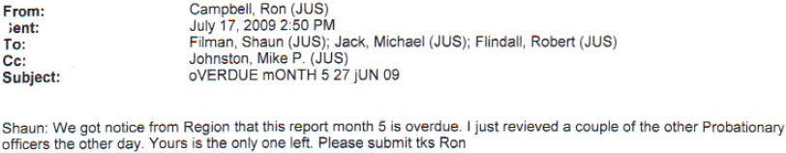

- As entered in exhibit 24 the OPP’s Probationary Constable Performance Evaluation Guidelines do make this differential treatment of the applicant more clear in that while the other probationary constables had their PER 5 done in compliance with the guidelines the applicant’s PER was not.

Ontario Provincial Police Orders, Probationary Constable Evaluation Report Guidelines:

- Exhibit 28, Ontario Provincial Police Orders, Administration & Infrastructure, 6.4, Human Resources, shows what is required of a coach officer:

- Unless the respondent intends to introduce evidence that the other three probationary recruits in the first 8 months of their probationary term did not have regular performance evaluation meetings with their respective supervisors, the applicant submits that he was the only one to be treated differently by being denied these meetings. This differential treatment was discriminatory and contrary to the OPP Orders and the direction provided to supervisors and detachment commanders. Orders that the applicant intends to introduce during cross examination of Sgt. Flindall, S/Sgt. Campbell and Insp. Johnston,
Ontario Provincial Police Orders, Law Enforcement, 2.51.1: Supervision – Member

Ontario Provincial Police Orders, Administration & Infrastructure, 6.4: Human Resources:

- The applicant testified about his first shift at Peterborough detachment which was a night shift. He did not even know the entry code for the side door and had to ask his classmate Cst. Amanda Knier to advise him which door to use and what code to enter. This task that he had to undertake was something that he ought not to have been done had either the coach officer or his immediate supervisor taken care of that, but they did not.

- As referenced in item 18 the applicant asserts that the denial in the response from the respondent does form a pretext to an admission of discrimination.
Respondent’s Response to the Application (HRTO 2010-07633-I), paragraph 36:

- The applicant testified about the numerous times he was reminded about his accent, told he had a funny accent, asked if he could speak with a Canadian accent and even told by his coach officer that Constable Filman (Senior) who was his father and also working out of Peterborough detachment but assigned to the Native reserve north of the detachment had told him that he shouldn’t say anything during his first year on the job. The applicant got the message and as a cumulative effect of those comments he reduced his radio communications to a bare minimum and in a multitude of instances resorted to using his personal cell phone instead of the radio for the fear of being reminded of his accent again. Simply put he was harassed because of his accent.

- Kaye Joachim commented in the Nassiah v. Peel (Regional Municipality) Services Board, 2007 HRTO 14:
I find that whether the question of English speaking ability is asked in the suspect’s presence or not, or whether it is posed to the suspect or not, this is a discriminatory practice when the reason or part of the reason for asking the question is because of the colour of the person’s skin.

- In the case of the applicant, he was asked this by Cst. Moran because he was a foreigner and did speak with a thick Russian accent. The question suggests that his accent is problematic and the fact that it was asked made the applicant crucially aware of his speech. The fact that it was asked made it discriminatory for it implied that his foreign accent was unacceptable.

- Further evidence that the applicant has in his possession that he intends to present is an email correspondence on August 02, 2009, from Sgt. Flindall to Insp. Johnston in reference to the applicant’s job with the OPP being in serious jeopardy.

- The applicant testified about an excerpt from that email from Sgt. Flindall:
‘PC Jack’s current employment with us is in serious jeopardy as a result of his actions and inactions’.
Emphasis added

- The applicant’s testimony was that when he was being chastised by Sgt. Flindall about not following his direction, Sgt. Flindall told him that he ‘never had such an incompetent recruit before.’ The applicant naturally asked if his job was in jeopardy to which Sgt. Flindall told him that it was.

- The applicant explained in his testimony that since his arrival at the Peterborough Detachment in January 2009 and until October 2009, he had not had a single proper performance evaluation meeting with his accountable supervisor, Sgt. Robert Flindall. During the cross-examination, suggestions were made that when his coach officer, Filman, discussed specific incidents with him that those discussions formed the required performance evaluation meetings. However, those suggested meetings failed to meet the standards described and directed by OPP Orders.

Ontario Provincial Police Orders, Probationary Constable Evaluation Report Guidelines:

- The applicant’s testimony and this piece of further evidence that he intends to introduce, coupled with the absence of performance evaluation meetings do strongly suggest that when it came to the applicant there was a total aberration of OPP Orders stemming from discrimination by differential treatment. It stands to reason that the applicant’s employment was in serious jeopardy as a result of whose inactions?

- The applicant expects to adduce evidence through the cross-examination of Sgt. Flindall consisting of 5 email correspondences regarding the Break and Enter investigation that will further applicant’s evidence to support discrimination by differential treatment and reprisals for exercising his rights under the Code.,

- As testified and uncontested through the cross-examination the applicant was the only one out of all his platoon members involved in this Break and Enter incident to receive a negative 233-10 documentation. Sgt. Flindall explicitly states in the email dated August 10, 2009, that all the officers involved would be getting a positive 233-10, but that simply did not apply for the applicant because as he had testified,

‘… there was the platoon and there was me.’
Emphasis added
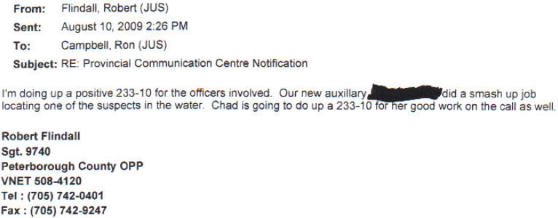
- The 233-10s that were issued to the officers were for their involvement at the scene in curtailing the alleged Break and Enter in progress. It was not for their subsequent involvement in the processing of the youths. Hence, the applicant rightfully should have been treated similarly and given a positive 233-10 for his involvement at the scene.

- The response to the application from the respondent is filled with lies that do form a pretext to an admission of discrimination as mentioned in item 18.
Respondent’s Response to the Application (HRTO 2010-07633-I), paragraph 38:
Respondent’s Response to the Application (HRTO 2010-07633-I), paragraph 50:

- Discrimination by differential treatment is additionally furthered by the testimony of the applicant of being denied developmental opportunities. The applicant’s testimony in his examination in chief here was,

‘… there was the platoon and there was me.’

The allegation and this portion of his testimony will be firmly established by an email that he reasonably intends to present through the cross-examination of Sgt. Flindall on the email he sent to S/Sgt. Campbell dated August 11, 2009. In it Sgt. Flindall is describing this alienation from the rest of the platoon while denying the applicant a developmental opportunity.
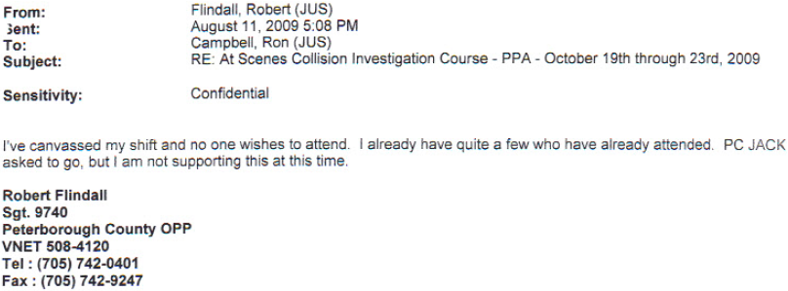

- The course would have been beneficial to the applicant’s policing career. The applicant was denied this mentoring and developmental opportunity. The notation from Sgt. Flindall’s statement in the email, ‘I’ve canvassed my shift and no one wishes to attend. PC Jack asked to go, …’ does describe this alienation for Sgt. Flindall did not even regard the applicant as an officer on his shift. Again, the respondent’s response to the application is a pretext to discrimination by differential treatment due to his race, ancestry and ethnic origin.
Respondent’s Response to the Application (HRTO 2010-07633-I), paragraph 53:

- Further evidence to be reasonably presented consisting of two emails on August 15, 2009, from Sgt. Flindall to the Non-Commissioned Officers, S/Sgt. Campbell and Insp. Johnston shows targeting of the applicant by Sgt. Flindall and discrimination by differential treatment. The applicant is prohibited by order of his Sergeant from working overtime and to cover for other officers.
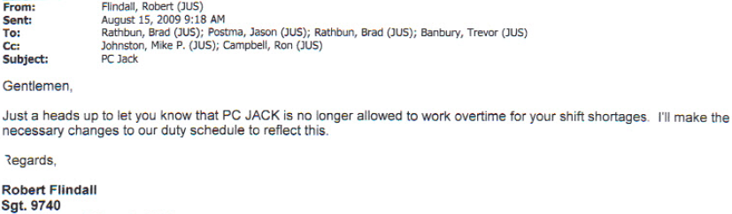
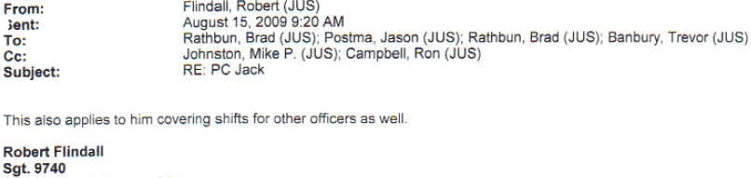

- The applicant’s testimony was that he was, ‘singled out by Sgt. Flindall and disallowed to work overtime on other shifts and for other people on other shifts.’ This was discrimination by differential treatment for it was not the same for everyone else on the platoon including the other probationary recruits on the other platoons. Yet the respondent states otherwise in their response to the application:
Respondent’s Response to the Application (HRTO 2010-07633-I), paragraph 46:
Respondent’s Response to the Application (HRTO 2010-07633-I), paragraph 47:
Respondent’s Response to the Application (HRTO 2010-07633-I), paragraph 53:

- As testified by the applicant, PER 5 was done by his coach officer, Cst. Filman. But being that his coach officer was on annual leave, Sgt. Flindall drove to Cst. Filman’s house and had him sign the PER. This PER 5 had no negative ratings. Though the applicant testified that Cst. Filman was ‘disinterested’ in the applicant and treated the applicant like a ‘leper’ he never openly harassed him. However, in treating the applicant in the manner the applicant testified Cst. Filman did discriminate against the applicant by differential treatment and unless the respondents are willing to put forth previous recruits trained by Cst. Filman who will testify to being treated similarly, the applicant’s testimony will remain unshaken for there is enough documentary evidence in these submissions to substantiate and corroborate these assertions of his.

- This differential treatment was noticed by the applicant in that he testified that other probationary recruits enjoyed the company of their coach officer sitting beside them while they did their occurrences and this interaction was often observed by the applicant during the period of time when the shifts overlapped by an hour and when at times the applicant either came early or remained at the detachment after his shift finished to do reports and also when he attended the detachment on his days off just to read up on occurrences and study on his own due to the lack of training from Cst. Filman. Cross-examination on this area centered on trying to discredit the applicant by pointing out a handful of individual occurrences wherein Cst. Filman did sit down beside the applicant at the computer and address questions the applicant had. However, the handful of times that he did this was due to questions from the applicant.

- The applicant testified that he worked hard to meet all the requirements on his monthly performance evaluations and even though the summer months were taxing on the whole detachment he was able to say that he spent a lot time during his days off and when off duty so that he could stay on top of his workload in the midst of all the racial discrimination he was being subjected to. This multitasking of his was something that was recognized by the investigators conducting his background investigation, but not at the detachment level. His testimony here did reveal that he worked more shifts than the rest of his platoon, had a greater caseload than the rest and was able to maintain the shortest task list. His testimony was also corroborated by the case load analysis conducted by Sgt. Flindall prior to preparing his PER 6/7.

- The applicant testified that later on that day shift of August 15, 2009, he was called into Sgt. Flindall’s office and charged under the Highway Traffic Act (HTA) for something that was completely false. The resulting trial in the matter which took place in the summer of 2010 did exonerate him and corroborate his assertion about the charge being false and frivolous – there simply was not enough evidence to substantiate the charge and as the applicant testified in his examination-in-chief there could not have been enough evidence because there was no reasonable grounds to lay the charge other than mere suspicions based on the limited view afforded to one via a rear view mirror.

- Testimony from the applicant also revealed that only 34 hours after being given his PER 5 with 0 ‘Does Not Meet Requirements’ he was given his PER 6/7 with 10 ‘Does Not Meet Requirements’. His testimony was that he personally observed Sgt. Flindall working on this PER 6/7. He was given just 15 minutes to read it over and sign it for it was shared with him without a performance evaluation meeting at 17:45 hrs and he was expected to sign it and return it by the end of the shift at 18:00 hrs. The applicant merely asked for more time to read it over and contacted his association branch president, Karen German.

- Since the applicant was off duty for the next 18 days, the applicant’s refusal to sign the document in the probationary recruit’s signature area was falsified by writing in the word ‘REFUSED’, commented and signed by S/Sgt. Campbell and sent to regional command staff in Orillia before the applicant returned to duty 18 days later thereby creating the perception amongst command staff that the applicant did refuse to sign the document and in doing so refused to accept accountability for his performance ratings.

- The influence the PER 6/7 had on regional command staff is evidenced in the briefing note of the respondent prepared to justify the termination of the applicant’s employment a few months later.

OPPs Career Development Bureau Briefing Note dated December 1, 2009

- His testimony was that he called the association due to the fact that he observed Sgt. Flindall work on this PER 6/7 which had 10 ratings of ‘Does Not Meet Requirements.’ The applicant also saw that the PER was starkly different in grammar and spelling from the ones he was privy to from his coach officer Cst. Filman. Aside from PER 6/7 not having a coach officer’s signature he also testified that the PER had almost no spelling errors. Though counsel tried to object to his testimony here during his examination in chief, the question then posed to him was,
Q. What did you notice about PER 5 and PER 6/7 considering that they were disclosed just a day and a half apart?
A. One was done by Cst. Filman and the other by Sgt. Flindall and Cst. Payne… The grammar and spelling were much different from that of Cst. Filman’s.

- Sgt. Flindall’s discriminatory treatment of the applicant was due to the applicant’s race, ancestry and place of origin as evidenced by the applicant’s thick Russian accent. Sgt. Flindall’s apparent dislike of the applicant dated back to late 2008 and the fact that his platoon now had a ‘Crazy Russian’ on it alias, ‘Crazy Ivan.’ The applicant testified that Sgt. Flindall simply did not like him and did also believe those initial emails in 2008 as referenced in this submission, that the OPP had made a mistake in granting the applicant employment.

- The question to be considered by this Tribunal with respect to PERs 1 – 5 and PER 6/7 is what made the ratings change so drastically? The answer is in the actual author of those PERs.

- The applicant does reasonably expect to tender documents obtained from the disclosure process that was in the exclusive possession of the respondent that will further corroborate his testimony of who actually worked and prepared his PER 6/7 and 8, namely an email correspondence on August 15, 2009, between Cst. Jenifer Payne and Sgt. Flindall and a copy of Cst. Payne’s notes for Aug. 19, 2009.
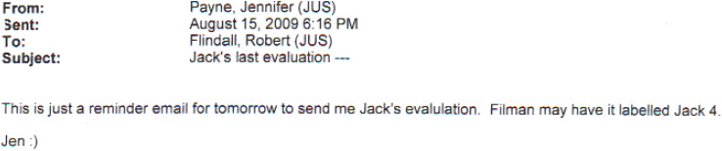
(August 19, 2009) Constable Jenifer Payne’s notes:
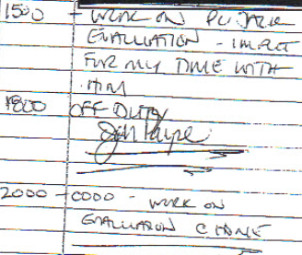 | 19 Aug 2009  15:00 work on PC Jack  evaluation – input  for my time with  him  1800 – OFF DUTY  JenPayne  -------------->  2000 – 0000 – work on  evaluation @ home  -------------->

(August 20, 2009) Constable Jenifer Payne’s notes:
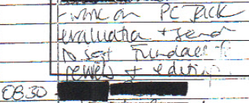 | 19 Aug 2009  0600 – ON DUTY  - work on PC Jack  evaluation + send  to Sgt. Flindall for  review + edition  08:30 [black]

- Once again the denial from the respondents in their response is a pretext to discrimination.
Respondent’s Response to the Application (HRTO 2010-07633-I), paragraph 46:

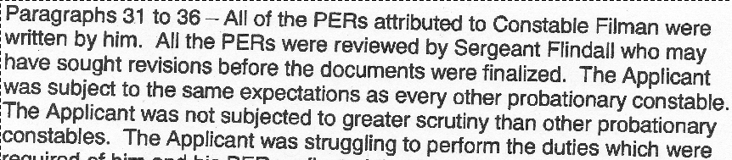
- The applicant intends to introduce into evidence through cross-examination of the personal respondents, an email correspondence between S/Sgt. Campbell, Insp. Johnston and Acting Superintendent Doug Borton (A/Supt. Borton) dated August 18, 2009, wherein the respondent admits to a possible Human Rights complaint coming from the applicant and the applicant’ work environment being poisoned. The email goes on to state that Sgt. Flindall had two platoons watching every move of the applicant and reporting back to him. Sgt. Flindall is also referenced as telling the applicant that his job was in jeopardy.
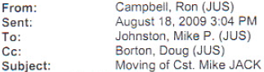
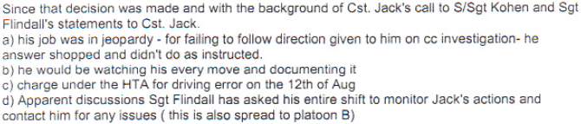
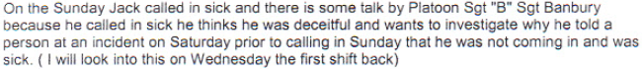
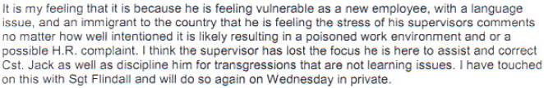
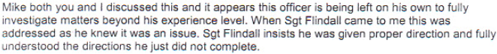

- The introduction of that email does establish a prima facie case of discrimination of all of the protected grounds as alleged in his application. No explanation whatsoever from the respondent can negate the admission of guilt contained therein. Key points that will be explored during cross-examination of S/Sgt. Campbell and Insp. Johnston are:
- Vulnerability of the applicant as a new employee and being an immigrant in the country,
- Applicant’s work environment being poisoned,
- Possible H.R. complaint,
- Applicant’s supervisor loosing focus with the applicant,
- Applicant being left on his own to fully investigate matters beyond his experience level.

- The applicant reasonably expects to present another email from Sgt. Flindall to S/Sgt. Campbell dated August 20, 2009, through the cross-examination of Sgt. Flindall that will afford evidence that Sgt. Flindall was concerned about his violations of the applicant’s rights under the Code. Though the respondent may argue that this email does not specifically state the reasons for the concerns of Sgt. Flindall, the order of emails and S/Sgt. Campbell’s mini-examination of Sgt. Flindall’s treatment of the applicant as contained in that August 18, 2009, email confirms the applicant’s assertion here.

- Further evidence expected to be introduced by the applicant in relation to the email correspondence on August 21, 2009, from S/Sgt. Ron Campbell to Insp. Mike Johnston will reveal that the applicant was targeted by his supervisor, Sgt. Flindall. The email when introduced through the cross-examination of S/Sgt. Campbell and/or the cross-examination of Insp. Johnston also confirms the applicant’s assertion as stated in item 60 does have merit and is not merely based on speculation for it reveals that Sgt. Flindall was not objective with the applicant.
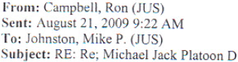
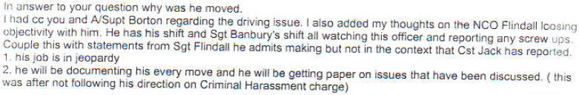
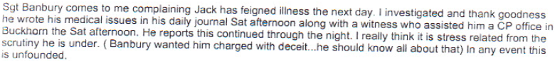

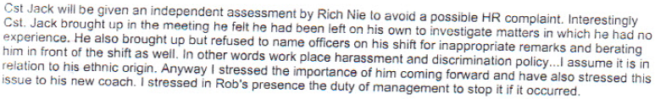

- The cross-examination of S/Sgt. Campbell on this email will reveal the following and corroborate the testimony of the applicant which was uncontested for the most part and unshaken through the few questions during his cross-examination:
- Sgt. Flindall loosing objectivity with the applicant,
- Sgt. Flindall having his entire shift and his brother-in-law, Sgt. Trevor Banbury’s shift all watching the applicant and reporting any screw ups,
- Statements from S/Sgt. Campbell regarding Sgt. Flindall that:
  - Applicant’s job was in jeopardy,
  - He would be documenting the applicant’s every move,
  - The applicant was stressed out from the scrutiny he was under,
  - That they were heading into an issue with the applicant as he is an immigrant of Jewish background,
  - That they (S/Sgt. Campbell and Insp. Johnston) both felt the applicant was being targeted,
  - The applicant’s work environment was poisoned,
  - The work place harassment and discrimination was taking place,
- The possibility of an HR complaint,
- The applicant was being left on his own to investigate matters in which he had no experience,
- That everything was being thrown at the applicant all at once without prior issues reported on his previous Performance Evaluation Reports,
- The applicant bringing to the attention of his supervisor Sgt. Flindall inappropriate remarks and being berated in front of the shift, but refusing to name officers.
- That the berating of the applicant and making inappropriate remarks to him was in relation to his ethnic origin,
- Asking Sgt. Flindall where was the coach officer who should be guiding this and where was the vetting of the briefs by him.

- Yet again, the respondent’s response to the allegations as contained in the application:
Respondent’s Response to the Application (HRTO 2010-07633-I):
- To add further insult to this Judicial Process the respondent did cause their counsel to violate her very oath she made to the Law Society of Upper Canada (Society), an oath to be truthful while maintaining impartiality in her representations so as not to bring the administration of the Society into disrepute. Counsel for the Respondent very conscientiously declared in section 21 of her response that she was telling the truth, yet her declaration was based on the initial lies fed to her by the respondents:
- The documentations, emails and statements that counsel used to prepare such a response were timestamped with a January 28, 2011, date. Counsel for the Respondent then signed this section and in doing so placed her credibility at stake.

- The Tribunal should clearly see how the Ontario Provincial Police violated the applicant’s fundamental rights as a Canadian Citizen, one deserving the protection under the Ontario Human Rights Code and had the audacity to deny doing so in the formal response to his application before this Tribunal.

- The applicant’s testimony was that immediately after being moved to a new platoon and being given a new coach officer under the guise of a fresh start he knew he was marked for termination. There were many incidents that gave rise to this feeling that he was marked for termination :
- being told his job was in jeopardy,
- the charge under the HTA,
- the stark increase in the negative ratings when Sgt. Flindall and Cst. Payne took over preparing his evaluations for PERs 6/7 and 8,
- forbidding him to work on his own,
- forbidding him to work paid duties,
- forbidding him to work overtime,
- moving him to work in a new patrol zone,
- the so called fresh start that tuned into living hell for him, and
- the completely false allegation of ‘associating with undesirables’

- This email between A/Sgt. Postma and S/Sgt. Campbell dated August 24, 2009, that the applicant intends to present will serve as evidence to what was causing this feeling. It will also corroborate his submission earlier about a plan/direction/action was put into place to keep him under surveillance and document his every mistake so as to justify the termination of his employment.

- In light of the above information, it is clear that Cst. Richard Nie was handpicked to finish the applicant off. This assertion is based on the following with supportive documentation that the applicant intends to present:
- Cst. Nie had a proven track record of being a coach officer the OPP could rely on to negatively document in detail to justify a termination of employment,
- Constable Nie had exercised this skill of his to justify the termination of minority probationer Mr. Harry Allen Chase,
- The applicant was deliberately placed on Cst. Nie’s shift since Sgt. Flindall had ‘lost the focus’ and they, being the next-door neighbors could easily confer together in order to get information from the opposite shift (while Platoon ‘B’ and Platoon ‘C’ worked days and nights, Platoon ‘A’ and Platoon ‘D’ were off) and in this way the OPP had coverage on all platoons (though this may sound far-fetched, consider the applicant’s often repeated belief – a surreptitiously orchestrated plan was put in place to scrutinize his every move/action and document them in order to justify his forced termination),
- Constable Nie’s biasness towards the applicant,
- Constable Nie’s lack of objectivity with the applicant,
- Constable Nie’s belittling treatment of the applicant,
- Constable Nie’s focus on the negative aspects of the applicant’s performance (according to Nie’s notes and point form chronology there was nothing positive worth mentioning about the applicant)
- Constable Nie’s meticulousness in documenting the applicant’s real and fabricated shortcomings over the following three months until his forced resignation. Notably is the fact that in the three (September 9 to December 14, 2009) months that the applicant spent with him, Cst. Nie had 44 pages of notes documenting his interaction with the applicant whereas in 8 months the applicant spent with his previous coach officer, Cst. Filman only had 15 pages of notes relating to the applicant.

- That email from A/Sgt. Postma will show that the so called fresh start for the applicant was nothing more than providing a false sense of hope to him while getting set to execute the respondent’s plan to justify the termination of his employment. It also shows that the applicant’s whole environment (detachment) was poisoned, not just his platoon. Yet he was being placed in the midst of platoon that felt they were the laughing stock of the detachment. The wording ‘these developments’ refer explicitly to the applicant, yet the respondents had the hypocrisy to say that the applicant was getting a clean and fresh start in the midst of this already poisoned work environment. The applicant testified about how he was made to feel like an ‘Undesirable’ and hence in the opinionated environment of a policing profession the applicant was already viewed as an “Undesirable”.
Respondent’s Response to the Application (HRTO 2010-07633-I), paragraph 31:

September 2009 to December 2009

- The applicant intends to introduce into evidence through the cross-examination of S/Sgt. Campbell an email Insp. Johnston dated September 3, 2009, wherein S/Sgt. Campbell advises Insp. Johnston that he had a meeting with Sgt. Flindall and issued him two negative 233-10s for his neglect and discreditable conduct towards the applicant’s training, development and supervision. In the email he notes that Sgt. Flindall was not happy receiving the documents and right after receiving them brings out an accusation of the applicant associating with organized crime. The 233-10s also serve to establish the respondent’s knowledge that the applicant was the only one being subjected to this type of treatment.

- The timing of that accusation was of paramount importance:
- Sgt. Flindall was negatively documented for his discreditable conduct towards the applicant and lack of supervision.
- Sgt. Flindall immediately proceeded to tell S/Sgt. Campbell that the applicant was hanging out with organized crime.

- The uncontested testimony of the applicant that no performance evaluation meeting ever took place with respect to his PER 8 and that the applicant’s refusal to sign PER 8 was falsified. On or about September 24, 2009, the applicant was served with his PER 8 with the applicant’s falsified refusal to sign it as is clearly evident from the word ‘REFUSED’ in place of the applicant’s signature. No performance evaluation meeting ever took place. The most heinous of which was the fact that on the alleged date of the PER 8 performance evaluation meeting September 11, 2009, the applicant was on his scheduled day off.

- The influence the PER 8 had on regional command staff is evidenced in the briefing note of the respondent prepared to justify the termination of the applicant’s employment a few months later.

OPPs Career Development Bureau Briefing Note dated December 1, 2009

- The applicant intends to present an email correspondence between Sgt. Flindall to Insp. Johnston on September 11, 2009, and on September 15, 2009, wherein is contained the allegation from Sgt. Flindall about the applicant associating with Albanian organized crime This email does identifies what Code protected group the organized crime are.

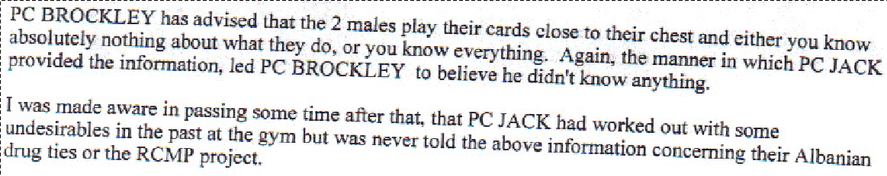
- Consequential to that email to Insp. Johnston the OPPs Professional Standards Bureau (PSB) was contacted and they sent the applicant a Notice of Internal Complaint alleging that he was being investigated for ‘associating with Undesirables’.

- The applicant did testify that this was a fabricated accusation and a blatant and malicious lie stemmed from Sgt. Flindall’s insatiable and vengeful appetite to mix applicant with dirt and terminate the applicant at all costs. The applicant terminology was strong here and he looked directly at the representative for the OPP seated behind counsel’s desk and with a fixed stare stated,

“It is something I will never forget and never forgive them for.”
Emphasis added

- The applicant’s testimony regarding this false allegation revealed that it stemmed from a 6 year old photograph of his standing in a gym with five other individuals. They were all Canadian citizens and they were all wearing shirts or t-shirts. Two of the individuals were known to the police to be Albanian organized crime individuals, but were not known to the applicant as such because at the time the photograph was taken, which was in 2003, the applicant was studying at Trent University then. The applicant merely showed that photograph to a couple of personal respondents in an attempt to confirm his own suspicion that he had in 2003 of one individual in the photograph being involved in sexual harassment. There was never any association or dealings with them other than them being part of a group of regulars that worked out at the same gym that the applicant did. Further allegations arose that the applicant had run the license plate of an unmarked police vehicle because of an association with those ‘Undesirable Canadian minorities’.

- The applicant’s testimony was that this allegation was on OPP letterhead thereby representative of the view of the infrastructure of the organization as a whole. Being that it was extremely humiliating to him when questioned further he did reveal that it was humiliating because no human being deserves to be labeled as an ‘undesirable.’ His response was not that no Canadian deserves to be labeled as such rather it was inclusive of all human beings everywhere. His response, unlike that of the OPP by that complaint was devoid of any hint of racism or systemic discrimination. The applicant’s testimony was also that it soon became common knowledge at the detachment that he was under investigation by PSB for ‘associating with undesirables’ and so he was treated like an undesirable.

- It is exactly evidence such as this the Tribunal must consider that if such evidence is introduced at trial it may lead to a finding of discrimination.

- Respondent cannot possibly defend against the allegation without putting forward any evidence on a balance of probabilities.
- Even so a prima facie case is established regardless of any response.
- The applicant will seek to present the concluded investigation report of Detective Sergeant Tym Thompson (D/Sgt. Thompson) sent to him November 19, 2009, that found the allegation to be lacking any substantive merit or ‘unfounded’. Though the investigating officer furnished the applicant with a copy of the concluded investigation earlier that it would have been shared with him if allowed to go through the normal process the damage had already been done. The respondent did achieve their goal through their plan of keeping the applicant under surveillance and negatively documenting his every mistake and as the months of the applicant’s probationary term progressed so did that plan. What was meant for negatively documenting his every mistake progressed into the fabrication and falsification of his monthly performance evaluation reports, the application of artificial and unsubstantiated charges under the Highway Traffic Act based on mere suspicion rather than reasonable grounds which in turn was used as a basis for further ratings of ‘Does Not Meet Requirements’ in his monthly performance evaluations to the ‘grand finale’ – that being the ‘Notice of Internal Complaint’ used in his PER 9 to further add to his negative ratings and justify the comments of his coach officer, Cst. Nie regarding the applicant not being recommended for permanent status.
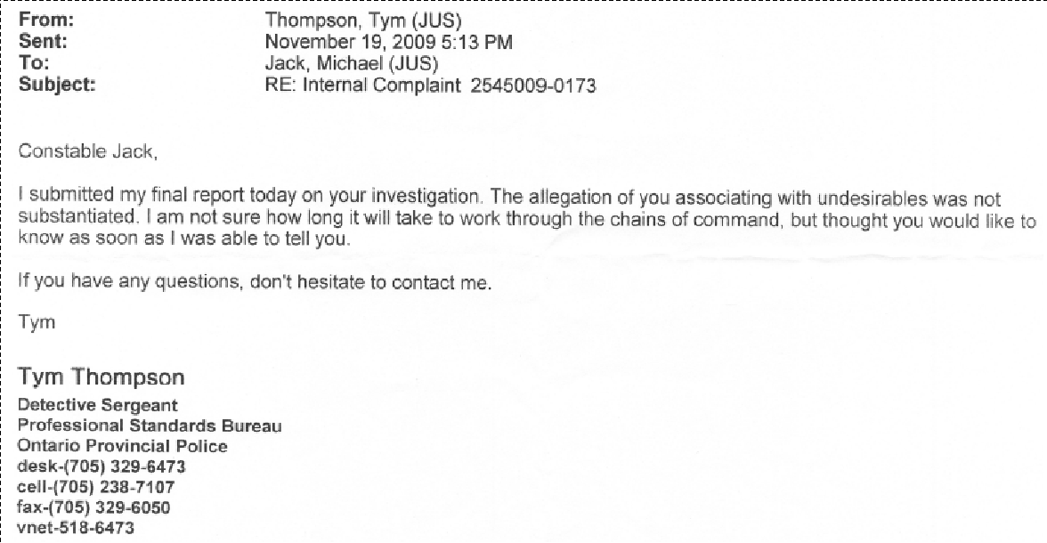
- As the applicant aptly testified during his examination-in-chief when questioned about what he wished to say about PER 9,
“I was like a lamb led to the slaughter.”
- After not recommending the applicant for permanent employment on his PER 10, Cst. Nie had the callous audacity in the applicant’s PER 11 to state, ‘that only the applicant’s interests were in his Sergeants and coaches attempts to help him pass.’,

Performance Evaluation Reports

- The following testimony regarding the individual categories of Performance Evaluation Reports 5, 6&7 and 8 were provided by the applicant and was unshaken during cross examination. In three categories the specific example from Performance Evaluation Report 5 with respective ratings of ‘Meets Requirements’ were carried over into Performance Evaluation Report 6&7 and 8 without any new information being added yet the ratings were changed to ‘Does Not Meet Requirements’ (as highlighted in bold print).
 | Served upon the applicant 34 hours apart
Category | Month 5  Dated: Aug. 19, 2009 | Month 6&7  Dated: Aug. 20, 2009 | Month 8  Dated: Sep. 11, 2009
Attitude Towards Learning | Meets Requirements | Meets Requirements | Does Not Meet Requirements
Provincial Statutes | Meets Requirements | Does Not Meet Requirements | Does Not Meet Requirements
Federal Statues | Meet Requirements | Does Not Meet Requirements | Meets Requirements
Police Orders, Procedures, Technical Skills | Meets Requirements | Meets Requirements | Meets Requirements
Police Vehicle Operations | Meets Requirements | Meets Requirements | Does Not Meet Requirements
Traffic Enforcement | Meets Requirements | Meets Requirements | Meets Requirements
Oral | Meets Requirements | Meets Requirements | Does Not Meet Requirements
Written | Meets Requirements | Meets Requirements | Does Not Meet Requirements
Listening Skills | Meets Requirements | Does Not Meet Requirements | Does Not Meet Requirements
Non-Verbal | Meets Requirements | Meets Requirements | Meets Requirements
Radio Communications | Meets Requirements | Does Not Meet Requirements | Does Not Meet Requirements
Community Focus | No Basis For Rating | Meets Requirements | Meets Requirements
Valuing Diversity | Meets Requirements | Meets Requirements | Meets Requirements
Decisive Insight | Meets Requirements | Meets Requirements | Meets Requirements
Analytical Thinking | No Basis For Rating | Meets Requirements | Does Not Meet Requirements
Resolution | Meets Requirements | Does Not Meet Requirements | Does Not Meet Requirements
Follow-Up Orientation | Meets Requirements | Does Not Meet Requirements | Does Not Meet Requirements
Initiative | No Basis For Rating | Meets Requirements | Meets Requirements
Personal Accountability | Meets Requirements | Does Not Meet Requirements | Does Not Meet Requirements
Planning & Organizing | Meets Requirements | Does Not Meet Requirements, | Does Not Meet Requirements
Flexibility | Meets Requirements | Meets Requirements | Meets Requirements
Integrity | Meets Requirements | Meets Requirements | Meets Requirements
Respectful Relations | Meets Requirements | Does Not Meet Requirements | Does Not Meet Requirements
Self-Confidence | Meets Requirements | Does Not Meet Requirements | Does Not Meet Requirements
Team Work | No Basis For Rating | Meets Requirements | Does Not Meet Requirements
Self-Awareness | No Basis For Rating | Meets Requirements | Does Not Meet Requirements
Deportment | Meets Requirements | Meets Requirements | Does Not Meet Requirements
Appearance | Meets Requirements | Meets Requirements | Meets Requirements

Termination of Employment
- The applicant testified that on the evening shift of December 13, 2009, he was taken by his supervisor, Sgt. Peter Butorac to the City of Kawartha Lakes detachment in Lindsay and presented to A/Insp. Mike Reynolds.

- Through further documents that the applicant reasonably intends to produce consisting of emails, briefing notes regarding his termination from employment, and point form chronologies of the personal respondents that the OPP used aside from his PERs to prepare the briefing notes will show the collective influence it had on command staff to terminate his employment.

- A/Insp. Reynolds advised the applicant that he had never done that before and then presented him with a Notice of Proposed Release from Employment advising him that before the decision was made regarding his termination the applicant would have an opportunity to make submissions. Though the applicant left there feeling extremely depressed he focused on the faint hope that document presented, that being that the ultimate decision to terminate would not be made until he had time to provide written and or oral submissions. However, adding to his feeling of depression was the fact that he had until December 15, 2009, to make these submission which gave him one day since he was working the evening shift which finished 6:00 am on December 14, 2009.

- Though he had managed to write his submissions and had them with him when he was driven to General Headquarters in Orillia he was literally ushered into the office of Chief Superintendent Mike Armstrong (Sup. Armstrong).

- The applicant noted that the Ontario Provincial Police Association (OPPA) board member Marty McNamara and Karen German were also present and seated to one side.

- The applicant was not given an opportunity to provide his written and neither was he asked if he had anything to say. The first question Sup. Armstrong asked the applicant was for his phone number which he wrote down on a document that was face up in front of him on his desk.

- Sup. Armstrong then told the applicant that he had reviewed the materials provided to him at the detachment level and the briefing notes and based on what he had read he gave the applicant two choices. Specifically he stated:
“ you have two options. Either sign this letter of resignation (and placed his hand of the document that was right in front of him) or be fired (placing his hand on a document that was on the right side of his desk).

- Neither of the OPPA representatives interceded at any time on his behalf.

- Presented with such an option and knowing that his life was ruined by some ruthless respondents at the detachment he selected the option that may at least have a lesser impact on an employer should he try to seek employment elsewhere. Hence, he signed the letter of resignation.

- Hence, his assertion in the application that he was forced to resign. An accurate impact of the termination of his employment is reflected in his testimony, ‘I was brought down on my knees and executed.’

Summary of Evidence

- The applicant’s testimony on day 7 was that of the five probationary recruits, one of whom was finishing his probationary term being that he was from another graduating class the applicant was the only one who was not local to Peterborough whereas the others were all locals. He was also the only minority amongst them and the only one who spoke with a noticeably thick accent. He in fact said that he was the only one who spoke with an accent out of everyone at the detachment.

- The Vice Chairman also questioned him about how many if any did not make it past their probationary period there. The applicant responded by advising that he was the only one not to pass the probationary period.

- The applicant testified that he was given a racially derogatory nick name and that the nickname was tied directly to his Code protected grounds of race, ancestry, place of origin and ethnic origin. His noticeable Russian accent is also related to those protected grounds.

- His testimony during re-examination on day 10 was that his coach officer Cst. Nie in PER 10 notes in the comments section that he was not recommending the applicant for permanent status. That those comments are dated November 10, 2009, yet in the very next PER 11 category’s Respectful Relations he saw that his coach officer stated on November 19, 2009, that the applicant was assured that only his interests were at hand in both his Sergeants and coaches attempts to help him pass. This PER 11 was given to the applicant the same day the Notice of Proposed Release from Employment was given. What more can one say?

- The applicant testified during re-examination that he did not provide a rebuttal to his PER 8 because by that time he had learned that providing rebuttals was futile, pointless and in fact made his situation only worse.

- With respect to the nick name and its effects the applicant testified on day 10 as to its roots. Specifically he testified that Ivan is Russian. He explained that for centuries Russians were known as Ivans and that in World War 2 the Germans referred to Russians as Ivans. Crazy Ivan is associated to Ivan the Terrible back in the 16th century when he was a Russian Czar and a war lord. Ivan the Terrible is notoriously known for his numerous atrocities against humans. So when they referred to the applicant as ‘Crazy Ivan’ they were actually saying ‘Crazy Russian’ since the applicant was born in Russia. So the applicant was being called crazy Russian. The applicant then said he did not know what was crazy about him.

- With respect to Big Kahuna the applicant said he did not know what it meant other than it referred to his representative, Lloyd Tapp.

- With respect to Big Brother he said that there was nothing derogatory about it because that was what Big Brother is. It is someone who watches over you and who exercises ultimate authority over you.

- In summary the Ontario Provincial Police’s overall treatment of the applicant was with animus furandi in racial discrimination of the applicant’s protected grounds as per his application.

Summary of Submission for Reasonable Prospect of Success

- In the case of the applicant:
- Uncontested facts that the applicant has never killed anyone, has never shot anyone, has never physically assaulted anyone, has never gone postal, has never associated with known criminals. All of those accusations were baseless, false and malicious. All stepping from prejudice and bias and none based on any evidence. In fact, the applicant dedicated his life to schooling and training. Prior to commencing his tenure with the OPP as a police officer the applicant had learned two foreign languages, had earned two college diplomas in Hebrew, two university degrees in science in English and another college diploma in English and had an impeccable performance and employment record. A question begs to be asked, “What is so special about being a police officer that the applicant could not do?”

- The word Ivan is slang for a Russian and the word Crazy is self-explanatory. In nick naming the applicant “Crazy Ivan” prior to him arriving at a very monocultural detachment the OPP was actually telling the detachment that a Crazy Russian was arriving. Consequently that nick name ignited a flame of Racism whereby detachment members were referencing the applicant as a Crazy Russian thereby poisoning the applicant’s work environment.

- This Racism permeated the whole of Peterborough OPP Detachment to the point of officers feeling comfortable to falsely accuse the applicant without the fear of reprisals.

- This Racism culminated to the point whereby the applicant’s performance evaluations were deliberately manipulated to portray negativity so that his employment would be in jeopardy and he would be forced into signing a resignation.
- This Racism that the applicant was subjected to negatively affected his abilities to seek similar employment from other Police Services since he was constantly advised that he had never successfully completed his probationary period with the Ontario Provincial Police.

- This Racism that the applicant was subjected shattered his goal of sponsoring his family from Israel.

- This Racism that the applicant was subjected to ruined him physically, mentally, emotionally, psychologically and financially.

- As a result of the overall Racism that the applicant experienced at the OPP he left Canada and returned to Israel.

- The applicant is mindful of the last case management conference held September 18, 2015 at 2:00 pm wherein counsel for the respondent, in addressing the number of witness offered to shorten the possible length of the hearing by mentioning that ‘if it is for the sake of admitting certain document then he had not objection to admitting the documents, but wanted to examine them first.’

- Though the applicant is paraphrasing his comment the meaning the applicant and his representative gleaned was that counsel for the respondent wanted to examine the documents to make sure they were authentic in its original form and had not been modified.

- Subject to any further questions from Vice Chair the applicant rests his submission.

Ontario Human Rights Code, R.S.O. 1990, c. H. 19, s. 5(1), Relevant Statutes, Schedule A, 1
Ibid, s. 5(2)
Ibid, s. 8
Ibid, s. 12
Ontario Human Rights Commission – Policy on Discrimination and Language, 2009, Schedule A, 2
OHRC brochure on Racism & Racial Discrimination, 2009, Schedule A, 3; Exhibit 92, Applicant’s statement, pgs. 67 & 68
Ibid
Ontario’s Human Rights Commission - Racial Harassment Brochure, 2009, Schedule A, 4
Ibid; Exhibit 92, Applicant’s statement, pgs. 67-68
Ontario Human Rights Commission v. Simpsons-Sears Ltd., [1985] 2 S.C.R. 536, at para. 28 ("O'Malley")
Dhanjal v. Air Canada, (1997), 139 F/T.R. 37 at para. 6
Pellerin v. Cobseil scolairede district chatholique Centre-Sud, 20112 HRTO 1777, para. 30, Applicant’s Book of Authorities
Dabic v. Windsor Police Service, 2010 HRTO 1994, para. 10
Ibid, para. 24, Applicant’s Book of Authorities
Ibid, para 11
Pellerin v. Cobseil scolairede district chatholique Centre-Sud, 20112 HRTO 1777, Applicant’s Book of Authorities
Ibid, pg1 at para. 1 and Exhibits 1 - 4
Ibid and Exhibit 13
Exhibit 11, OPPs offer of employment
Exhibit 92, Applicant’s statement, pg. 5, para. 1; pg. 6, para. 2
Ibid, pg. 5, para. 1
Email from Sgt.; Rathbun dated August 5, 2008, Schedule B, 1
Exhibit 92, Applicant’s statement, pg. 6, para. 2
Ibid, pg. 5, para. 1
Emails between Insp. Johnston S/Sgt. Campbell, Command Staff in Orillia and results of the second background investigation of the applicant, August 5 to19, 2008, Schedule B, 2
Exhibit 7, Peterborough Fish and Game Association Membership
Exhibit 92, Applicant’s statement, pg. 6, para. 3
Exhibit 92, Applicant’s statement, pg. 6, para. 2
Ibid, pgs. 5-6
Jacqueline Nassiah v. Peel Regional Police Service, OHRT 2007, Applicant’s Book of Authorities
Ibid, para. 166
Exhibit 92, Applicant’s statement, pg. 6
Respondent’s Response to Application, para. 28
Exhibit 92, Applicant’s statement, pg. 5, para. 2, 3.
Emails dated September 4 and 24, 2008 and Internal Briefing Report (‘documents’), Schedule B, 3
Exhibit 92, Applicant’s statement, pg. 6, para. 3, pg. 66, para 1.
OPP Police Orders, Probationary recruits ceremonies, Schedule B
Exhibit 92, Applicant’s statement, pg. 19
Exhibit 92, Applicant’s statement, pgs. 52-56
Email from S/Sgt. Campbell dated July 17, 2009, Schedule B, 4
Exhibit 92, Applicant’s statement, pgs. 25-30
Exhibit 24, OPP Probationary Constable Evaluation Report Guidelines
Exhibit 28, OPP Human Resources, Probationary Constables
Exhibit 27, OPP Orders, Law Enforcement, 2.51.1: Supervision – member
Exhibit 28, OPP Orders, Human Resources, Probationary Constables
Respondent’s response, para. 36
Exhibit 92, Applicant’s statement, pg. 10, para. 6
Ibid, pg. 10, para. 7
Ibid, pg. 42, para. 4
Nassiah v. Peel (Regional Municipality) Services Board, 2007 HRTO 14
Exhibit 92, Applicant’s statement, pg. 10, para. 5
Email from Sgt. Flindall to Insp. Johnston dated Aug. 2, 2009, Schedule B, 5
Exhibit 92, Applicant’s statement, pg. 18, para. 4
Exhibit 24, OPP Probationary Constable Evaluation Report Guidelines
Exhibit 92, Applicant’s statement, pg. 20, para. 3-5
Ibid, pg. 20, para. 1-2
Email correspondences regarding the Break and Enter, Schedule B, 6
Exhibit 92, Applicant’s statement, pg. 20, para. 6
Respondent’s response, para. 38
Email from Sgt. Flindall to S/Sgt. Campbell dated August 11, 2009, Schedule B, 7
Respondent’s response, para. 53
Emails from Sgt. Flindall dated August 15, 2009, Schedule B, 8
Exhibit 92, Applicant’s statement, pg. 6, para. 3, pg. 7, para. 2, pg. 8, para. 2, pg. 9, para. 3-4
Exhibit 19, pg. 7, Team Work, Appearance
Exhibit 92, Applicants statement, pg. 7, para 1
Ibid, pgs. 11 - 14
Ibid, pgs. 21-22
Exhibit 29, HTA proceedings
Exhibit 92, Applicant’s statement, pg. 31
OPPs Career development Bureau briefing notes dated December 1, 2009, Schedule B, 17
Exhibit 92, Applicant’s statement, pg. 31
Email from Cst. Payne dated August 15, 2009, and notes dated Aug. 19, 2009, Schedule B, 9
Email from S/Sgt. Campbell dated Aug. 18, 2009, Schedule B, 10
Email from Sgt. Flindall to S/Sgt. Campbell dated Aug. 20, 2009, Schedule B, 11
Email from S/Sgt. Campbell to Insp. Johnston dated Aug. 21, 2009, Schedule B, 12
Exhibit 92, Applicant’s statement, pg. 33, para. 2
Email from Sgt. Postma to S/Sgt. Campbell dated august 24, 2009, Schedule B
Exhibit 92, Applicant’s statement, pg. 46, para. 5, pg. 59, para. 1
Ibid, pg. 4, 32, 33 at para. 2
Exhibit 92, Applicant’s statement, pg. 44, para. 3
Email from S/Sgt. Campbell dated September 3, 2009, Schedule B, 14
Exhibit 92, Applicant's statement, pgs. 38-39
OPPs Career development Bureau briefing notes dated December 1, 2009, Schedule B, 17
Emails from September 11, 2009, and September 15, 2009, Schedule B, 15
Exhibit 46, Notice of Internal Complaint
Exhibit 92, Applicant’s statement, pgs. 48 - 50
Dabic v. Windsor Police Service, 2010 HRTO 1994 at para. 9
Ont. Human Rights Comm. V. Simpsos-Sears, [1985] 2 S.C.R. 536 (“O’Malley”)
Exhibit 92, Applicant’s statement, pg. 41, para. 4.
Concluding report re: Notice of Internal complaint, Schedule B, 16
Exhibit 92, Applicant’s statement, pg. 43, para. 3.
Exhibit 61, pg. 10
Exhibit 92, Applicant’s statement, pg. 50, para. 5.
Exhibit 64, pgs. 8-9, Respectful Relations category
Exhibit 33, Exhibit 34, Attitude Towards Learning
Exhibit 35, Exhibit 36, Attitude Towards Learning
Exhibit 34, Listening Skills
Exhibit 36, Listening Skills
Exhibit 36, Analytical Thinking
Exhibit 21, Resolution
Exhibit 34, Resolution
Exhibit 36, Resolution
Exhibit 36, Ibid
Exhibit 34, Planning & Organizing
Applicant’s List of Exhibits to be Relied Upon, Exhibit 47, 47a-d
Exhibit 36, Ibid
Exhibit 34, Respectful Relations
Exhibit 36, Ibid
Exhibit 34, Self-Confidence
Exhibit 36, Ibid
Exhibit 92, Applicant’s statement, pgs. 52-53
Exhibit 92, Applicant’s statement, pgs. 53-55
Exhibit 92, Applicant’s statement, pg. 55
Exhibit 61, pg. 10
Exhibit 92, Applicant’s statement, pg. 43, paras. 2-3
Exhibit 92, Applicant’s statement, pg. 1, para. 1; pg. 2, para 5

